**Ha Long Honeymoon Tour 3 Days 2 Nights**

*Attention:*

-Departure point: Hanoi.

-Time: 3 days 2 nights.

-Media: car

-Price: 3100000đ.

-Image:

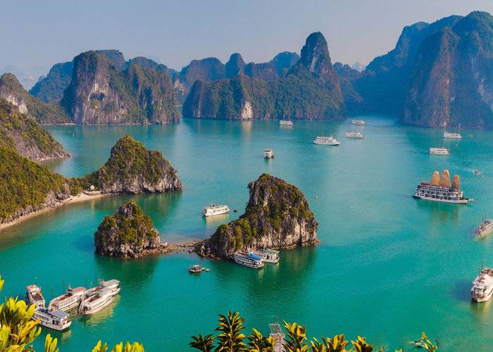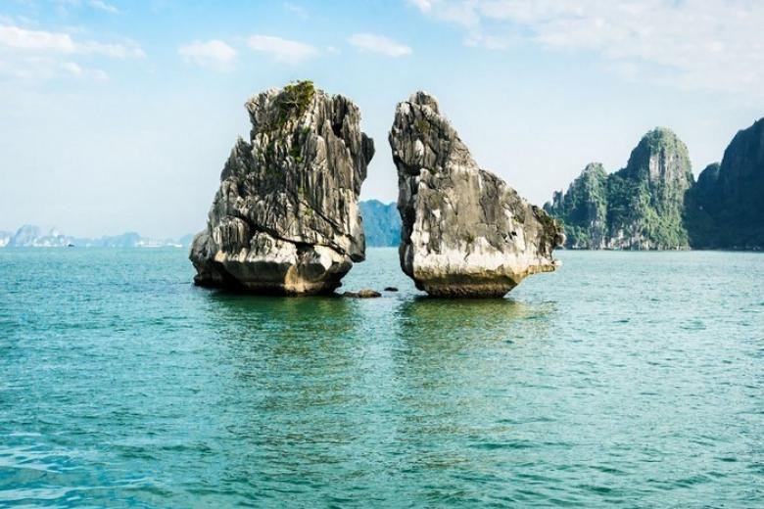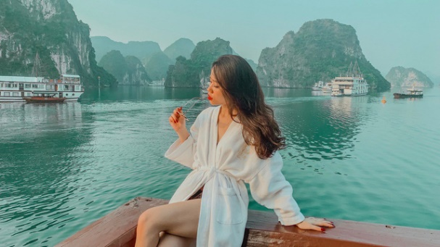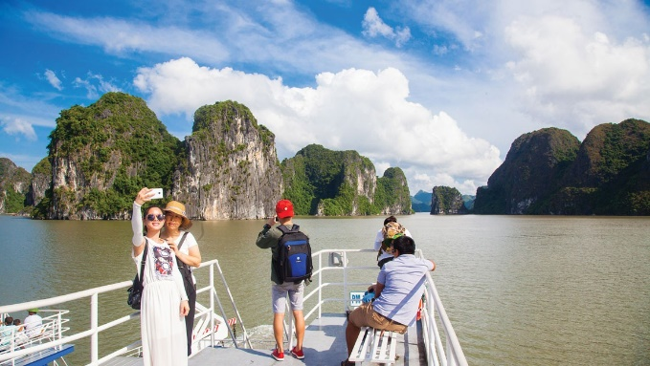

**I.Introduce:**

**Ha Long Honeymoon Tour**

**Ha Long** is an ideal destination which cannot be more beautiful because of its beautiful romantic charm, where couples will show their love for all couples, Vietcenter specializes in organizing honeymoon tours. for couples, helping them to keep the happy images after the wedding ... Let us help you love each other more! **Ha Long Bay** - Unesco has repeatedly recognized as a natural heritage of the world with thousands of islands made by magnificent and vivid creation. Halong Bay has a beautiful landscape, so this place is a very attractive tourist destination for domestic and international visitors.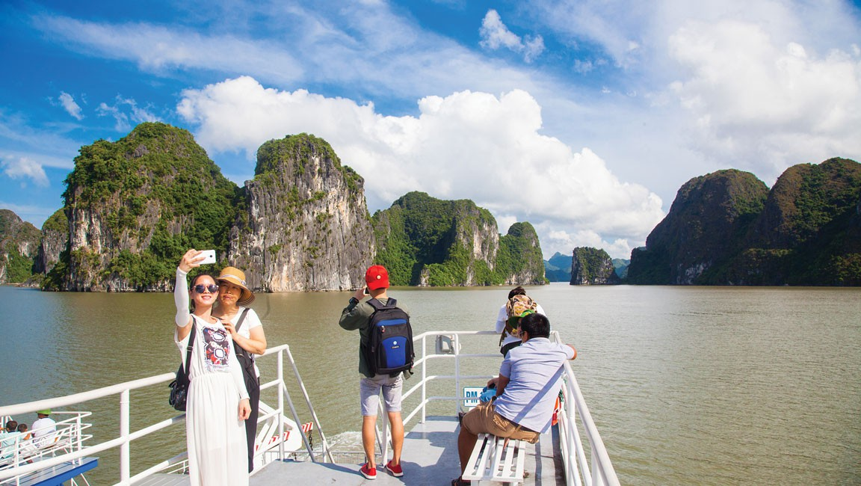

**Halong Bay features a beautiful system of rocky islands and caves. The island in Ha Long has two forms: limestone and shale islands, concentrated in the two main areas of the southeast region of Bai Tu Long Bay and the southwest of Ha Long Bay. This is the oldest image of the terrain with the age of geological tectonics from 250 to 280 million years, as a result of the movement of raising, lowering and descending many times from the continent to the sunken area. The process of erosion and weathering of Carxto almost completely creates a unique Ha Long in the world.**

Hundreds of stone islands, each island has a very different shape very vivid: Head Island, Dragon Island, La Vong Island, Canh Buom, Ga Choi Stone, Lu Huong Island ... the beautiful caves associated with many miraculous legends such as Thien Cung cave, Dau Go cave, Sung Sot cave, Trinh Nu cave, Tam Cung cave ... These are really castles of creation in the middle of the earth. Since ancient times, Ha Long has been called by the great poet Nguyen Trai, the "wonder of the land built in the sky".

**II.** **Tour schedule:**

**1.Day 1:**

**HA NOI – HA LONG**

_____________________________________________________________________

In the morning: Pick up at your departure home at Ha Long to start your honeymoon trip.

Coming to Ha Long, the two of you will be welcome on the yacht, designed, decorated with candles, flowers, wine and chocolate are ready for you two on the boat.

Noon: Lunch will be served while the boat starts to take you two to explore Ha Long Bay. After taking you to explore the karst areas along with the most beautiful caves on the bay, the boat will anchor at Titop beach. Late afternoon cruise will take you two to visit the fishing village at sea before attending a cocktail at sunset on board.

Evening: Dinner and overnight on the boat

_____________________________________________________________________

**2.Day 2:**

**TOGETHER DISCOVER HA LONG BAY**

_____________________________________________________________________

Morning: After breakfast the two of you will have a full day above Halong Bay. You can relax on pristine beaches, kayak through small mountain caves into isolated coves inside the small mountains and explore Ha Long Bay in the most detailed way.

Noon: Private chefs will prepare lunch on board at any time you want or you can spend time together on a separate beach with a charcoal stove or travel gas stove, cooking for each other your lunch

Evening: Dinner and overnight on the boat

_____________________________________________________________________

**3.Ngày 3:**

**HA LONG– HA NOI**

_____________________________________________________________________

You can start the day by sitting together to catch the sunrise on the deck. After breakfast, the boat will continue to take you to explore Ha Long Bay before taking you back to the wharf. Our private car was waiting at the pier and we departed for Hanoi.

Finish this memorable honeymoon tour.

_____________________________________________________________________

**III.** **INCLUDED AND TERMS:**

**Service includes:** • New and luxurious 4-seater car servicing on the tour• Cruise on the tour• Eating meals program• Sightseeing: One-time admission to attractions in the program• Discover Halong Bay by kayaking on the second day of the tour• Candles, flowers, chocolate and wine in the first day room at the train• Professional, enthusiastic, thoughtful tour guide **The service does not include:** • Other meals, drinks.• Personal costs• Costs not included in the honeymoon tour.• Travel insurance• 10% VAT